

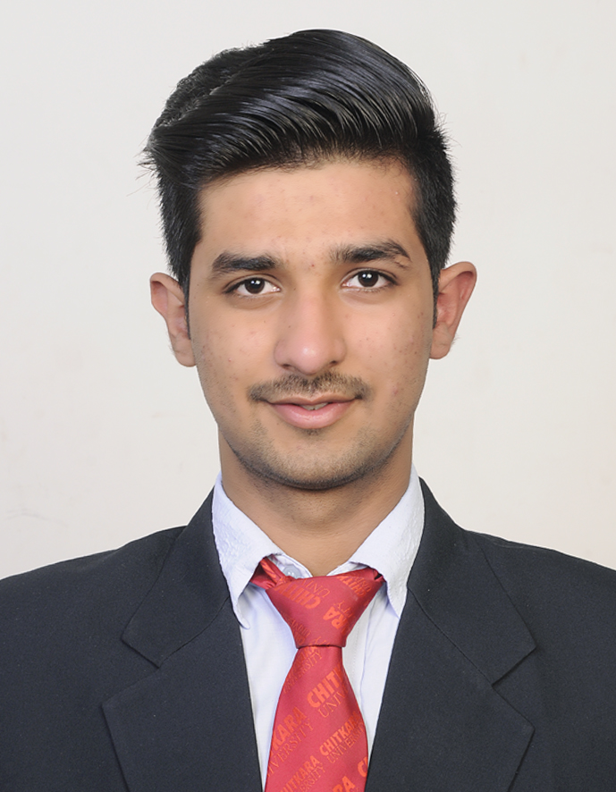

SAURABH MANCHANDA

S/o: Mr. Pardeep Kumar

House No. 1845 Samadhi Gate Manimajra,

Chandigarh.

+91 8146617504

Saurabhmanchanda1612@gmail.com

*Seeking a Position with a Reputed Organization that helps to utilize my Technical, Analytical skills & also provide the opportunity to gain additional skills and experience.*

***EDUCATION***



|  |  |  |  |
| --- | --- | --- | --- |
| **QUALIFICATION/ DEGREE** | **SCHOOL/COLLEGE** | **UNIVERSITY OR BOARD** | **YEAR** |
| B.E.(CSE) | CHITKARA SCHOOL OF ENGINEERING AND TECHNOLOGY | CHITKARA UNIVERSITY | 2014-2018 |
| CLASS XII | Moti Ram Arya Senior Secondary School (Chd) | C.B.S.E | 2014 |
| CLASS X | Moti Ram Arya Senior Secondary School (Chd) | C.B.S.E | 2012 |

***CAREER RECITAL***



* 6 weeks Training on C, C++. (June 2015)
* 6 weeks Training on Core Java. (June 2016)

***ACADEMIC PROJECTS***



* Project on Seven Wonder static website. (2015)
* Project on C.V Generator (Standalone Application using Java). (2016)
* Project on component of Search Engine (Crawler). (2017)
* Currently working on dynamic shopping cart website using JavaScript & HTML. (2017)

***PROFESSIONAL SKILLS***



* Programing Language: C, C++, HTML, Core Java, Basics of JavaScript, Scratch.
* Operating Systems : Microsoft Windows 10, LINUX.
* Database Packages: MySQL.
* Software: JDE, Netbeans, Android studio, Cisco Packet Tracer, Dev C++, Brackets.

***CO-CURRICULAR ENGAGEMENTS***



* Organized many events of Math Pirates Club. (2015-2017)
* Attended National Service Scheme Camp at CHITKARA UNIVERSITY (2016).
* Organized as a team committee of a Cultural-fest held at Chitkara University in 2016.
* Part of National Service Scheme at CHITKARA UNIVERSITY. (2015-2016)
* Organized as a team committee of a Technical fest held at Chitkara University in 2015.
* Organized as a team committee of a Fresher Party held at Chitkara University in 2015.
* Organized as volunteer in orientation held at Chitkara University in 2015.
* Organized many events of N.S.S like Blood Donation Camp.
* Participated in C-Champ (Coding Competition) organized by SAP in a Technical Fest.
* Participated in many events Like Modeling, Singing and Coding Events.
* Participated in many events like GTQ, Technical Treasure Hunt.
* Participated in many mathematical quiz like Math-U-See.
* Anchored Event in School (Farewell and Fresher Party).
* Participated in Photography Event ‘CLICK OF THE FEST’.

***ACIEVEMENTS***



* President of Club Math-pirates at CHITKARA UNIVERSITY. (2016-2017)
* Zonal head of Abhivyakti (Acting Zone) during cultural Fest. (2016)
* Event head of many events during college Fest. (2015)
* Third Prize in Singing competition.
* Successfully completed course on Programming in Scratch from edX.
* Successfully completed course on idea generation methods from iversity.
* First Prize in Writing Competition.

***INTERESTS AND HOBBIES***



* Singing.
* Surfing Internet.
* Playing Football.
* Travelling.

***POSITIVE TRAITS***



* Optimistic Attitude.
* Ambitious, a strong desire “To Do” something different.
* Keen to Learn and Explore new things.
* Cooperative & Adaptive.
* Good Listener and Communicator.

SAURABH MANCHANDA

ID - 1411981206